A000-AM,S-Peru-Vicus-Mask-Funerary-Feline-Copper-100 BCE-600 CE

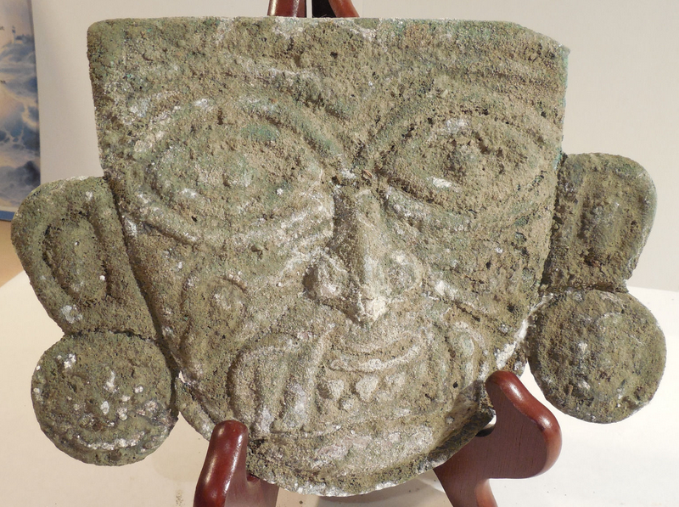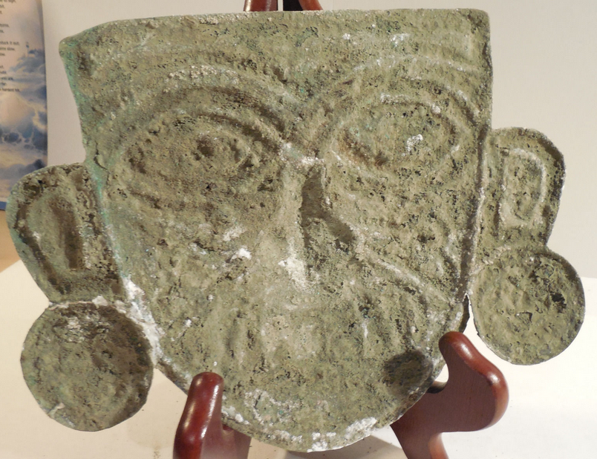

**Case No.: 7**

**Accession No.**

**Formal Label:** Peru-Vicus-Shaman Mask-Copper-100 BCE-600 CE

**Display Description:**

This Vicus Copper Shaman Mask was made by the Vicus Culture copper smiths of NW coastal Peru. This copper mask is in the form of a metaphorical feline Warrior probably a jaguar. He has fangs coming from his mouth suggestive of a superior feline predator and facial tattoos and scarifications that link him to a special group of warriors within his military society. He has large ear spools indicative of his élite status (the bottom of the right one was repaired). This ancient artifact has heavy oxidation accrued from its emplacement in tomb and dents accrued from this emplacement.

**LC Classification:** GN570.P3

**Date or Time Horizon:** 100 BCE-600 CE

**Geographical Area:** NW coastal Peru

**Map:**

**GPS coordinates:**

**Cultural Affiliation:**

**Medium: copper**

**Dimensions:**

**Weight:**

**Condition:** original

**Provenance:**

**Discussion:**

The Vicus culture flourished in NW Peru with its capitol near present-day Vicus, Trujillo, from 300 BCE-300 CE, during the Early Intermediate Period. Vicus settlements were hierarchically organized as autonomous polities but shared a common élite warrior culture, as seen in the feline  iconography of this mask.

**References:**

* American Museum of Natural History, ["Mexican and Central American Virtual Hall"](http://anthro.amnh.org/anthropology/research/mca_objects.cfm?case_number=3), accessed April 2008.
* Beekman, Christopher S. (1996). [*"Political Boundaries and Political Structure: The Limits of the Teuchitlan Tradition"*](https://web.archive.org/web/20090306000631/http:/carbon.cudenver.edu/~cbeekman/articles/am96pap.pdf) (PDF). [*Ancient Mesoamerica*](https://en.wikipedia.org/w/index.php?title=Ancient_Mesoamerica_(journal)&action=edit&redlink=1). London and New York: [*Cambridge University Press*](https://en.wikipedia.org/wiki/Cambridge_University_Press). **7** (1): 135–147. [*doi*](https://en.wikipedia.org/wiki/Digital_object_identifier):[*10.1017/S0956536100001346*](https://doi.org/10.1017/S0956536100001346). [*ISSN*](https://en.wikipedia.org/wiki/International_Standard_Serial_Number) [*0956-5361*](https://www.worldcat.org/issn/0956-5361). [*OCLC*](https://en.wikipedia.org/wiki/OCLC) [*88113895*](https://www.worldcat.org/oclc/88113895). Archived from [*the original*](http://carbon.cudenver.edu/~cbeekman/articles/am96pap.pdf) ([*PDF*](https://en.wikipedia.org/wiki/PDF) online facsimile) on 2009-03-06.
* Beekman, Christopher S. (December 2000). [*"The Correspondence of Regional Patterns and Local Strategies in Formative to Classic Period West Mexico"*](http://carbon.cudenver.edu/~cbeekman/articles/jaa00.pdf) ([*PDF*](https://en.wikipedia.org/wiki/PDF) online facsimile). [*Journal of Anthropological Archaeology*](https://en.wikipedia.org/wiki/Journal_of_Anthropological_Archaeology). Orlando, Florida: [*Academic Press*](https://en.wikipedia.org/wiki/Academic_Press). **19** (4): 385–412. [*doi*](https://en.wikipedia.org/wiki/Digital_object_identifier):[*10.1006/jaar.1999.0354*](https://doi.org/10.1006/jaar.1999.0354). [*ISSN*](https://en.wikipedia.org/wiki/International_Standard_Serial_Number) [*0278-4165*](https://www.worldcat.org/issn/0278-4165). [*OCLC*](https://en.wikipedia.org/wiki/OCLC) [*201247825*](https://www.worldcat.org/oclc/201247825).
* Bruhns, Karen Olsen (1994) *Ancient South America*, Cambridge World Archaeology series, Cambridge University Press, [ISBN](https://en.wikipedia.org/wiki/International_Standard_Book_Number) [978-0-521-27761-7](https://en.wikipedia.org/wiki/Special:BookSources/978-0-521-27761-7).
* Christensen, Alexander F. (1999) "Review of *Ancient West Mexico: Art and Archaeology of the Unknown Past*", *Ethnohistory*, Vol 46, No 3, pp. 627–630.
* [Coe, Michael](https://en.wikipedia.org/wiki/Michael_D._Coe) (1994) *Mexico, from the Olmecs to the Aztecs*, Fourth Edition, Thames and Hudson, [ISBN](https://en.wikipedia.org/wiki/International_Standard_Book_Number) [0-500-27722-2](https://en.wikipedia.org/wiki/Special:BookSources/0-500-27722-2).
* Coe, Michael and Dean Snow and Elizabeth Benson (1986) *Atlas of Ancient America*; Facts on File, New York.
* Covarrubias, Miguel (1957) *Indian Art of Mexico and Central America*, Alfred A. Knopf, New York.
* Crossley, Mimi, ["Unknown Mexico/México Desconocido"](http://www.humanities-interactive.org/unknown/unknowntext.htm), accessed June 2008.
* Danien, Elin (2004) ["On the Dilemma of a Horn: the Horned Shamans of West Mexico"](http://130.91.80.97:591/PDFs/46-1/On%20the%20Dilemma.pdf) in *Expedition - Philadelphia*, Vol 46, pp. 22–35.
* Foster, Michael (2000) *Greater Mesoamerica: The Archaeology of West and Northwest Mesoamerica*, University of Utah Press, [ISBN](https://en.wikipedia.org/wiki/International_Standard_Book_Number) [978-0-87480-655-7](https://en.wikipedia.org/wiki/Special:BookSources/978-0-87480-655-7).
* Hosler, Dorothy (1995) *The Sounds and Colors of Power: The Sacred Metallurgical Technology*, The MIT Press, [ISBN](https://en.wikipedia.org/wiki/International_Standard_Book_Number) [978-0-262-08230-3](https://en.wikipedia.org/wiki/Special:BookSources/978-0-262-08230-3)
* International Council of Museums Red List, ["Nayarit figures (Mexico)"](http://icom.museum/redlist/LatinAmerica/english/page04.htm), accessed April 2008.
* Instituto de Arte Contemporáneo (Lima, Peru). 1965.  Universidad Técnica de Piura. Lima : Ediciónes del Instituto de Arte Contemporaneo, Serie origenes del arte peruano.
* López Mestas C., Lorenza and Jorge Ramos de la Vega (2006) "Some Interpretations of the Huitzilapa Shaft Tomb", in *Ancient Mesoamerica*, vol. 17, pp. 271–281.
* Kan, Michael (1989) "The Pre-Columbian Art of West Mexico: Nayarit, Jalisco, Colima" in *Sculpture of Ancient West Mexico, Nayarit, Jalisco, Colima*, Los Angeles County Museum of Art, University of New Mexico Press, [ISBN](https://en.wikipedia.org/wiki/International_Standard_Book_Number) [0-8263-1175-X](https://en.wikipedia.org/wiki/Special:BookSources/0-8263-1175-X).
* Kappelman, Julia [Art 347L "Mesoamerican Art Syllabus: West Mexico"](http://www.utexas.edu/cofa/a_ah/dir/precol/west_mexico.htm), accessed April 2008.
* Kubler, George (1984) *The Art and Architecture of Ancient America: The Mexican, Maya and Andean Peoples*, Pelican History of Art, Yale University Press, [ISBN](https://en.wikipedia.org/wiki/International_Standard_Book_Number) [0-300-05325-8](https://en.wikipedia.org/wiki/Special:BookSources/0-300-05325-8).
* Meighan, Clement W.; H. B. Nicholson (1989) "The Ceramic Mortuary Offerings of Prehistoric West Mexico: an Archaeological Perspective" in *Sculpture of Ancient West Mexico, Nayarit, Jalisco, Colima*, Los Angeles County Museum of Art, University of New Mexico Press, [ISBN](https://en.wikipedia.org/wiki/International_Standard_Book_Number) [0-8263-1175-X](https://en.wikipedia.org/wiki/Special:BookSources/0-8263-1175-X).
* Michelet, Dominique (2000) "Western Mexico" in *The Oxford Encyclopedia of Mesoamerican Cultures*, David Carrasco, ed., Catherine Sifel, Marhe Imber, translators, Oxford University Press, pp. 328–333, [ISBN](https://en.wikipedia.org/wiki/International_Standard_Book_Number) [978-0-19-514257-0](https://en.wikipedia.org/wiki/Special:BookSources/978-0-19-514257-0).
* [Metropolitan Museum of Art](https://en.wikipedia.org/wiki/Metropolitan_Museum_of_Art), Timeline of Art History, accessed April 2008.
* Smithsonian National Museum of the American Indian (2005) *Born of Clay: Ceramics from the National Museum of the American Indian*, NMAI Editions, [ISBN](https://en.wikipedia.org/wiki/International_Standard_Book_Number) [1-933565-01-2](https://en.wikipedia.org/wiki/Special:BookSources/1-933565-01-2).
* Sund, Judy (2000) ["Beyond the Grave: The Twentieth-Century Afterlife of West Mexican Burial Effigies"](http://findarticles.com/p/articles/mi_m0422/is_/ai_69411773), the Art Bulletin.
* Taylor, R. E. (1970) "The Shaft Tombs of Western Mexico: Problems in the Interpretation of Religious Function in Nonhistoric Archaeological Contexts", in *American Antiquity*, Vol. 35, No. 2 (Apr., 1970), pp. 160–169.
* Toscano, Salvador (1946) "El Arte y la Historia del Occidente en Mexico" in *Arte Precolombino del Occidente de Mexico*, Salvador Toscano, Paul Kirchoff, Daniel Rubin de la Borbolla, eds., Palacio de Bellas Artes, Mexico City, pp. 9–33.
* Weigand, Phil (2001) "West Mexico Classic" in *Encyclopedia of Prehistory*, Vol 5, [Peter N. Peregrine](https://en.wikipedia.org/wiki/Peter_N._Peregrine) and [Melvin Ember](https://en.wikipedia.org/wiki/Melvin_Ember) (eds), [ISBN](https://en.wikipedia.org/wiki/International_Standard_Book_Number) [978-0-306-46259-7](https://en.wikipedia.org/wiki/Special:BookSources/978-0-306-46259-7).
* Williams, Eduardo ["Prehispanic West México: A Mesoamerican Culture Area"](http://www.famsi.org/research/williams/index.html), Foundation for the Advancement of Mesoamerican Studies, Inc. (FAMSI), accessed April 2008.

Appendix:

Additional Views of Mask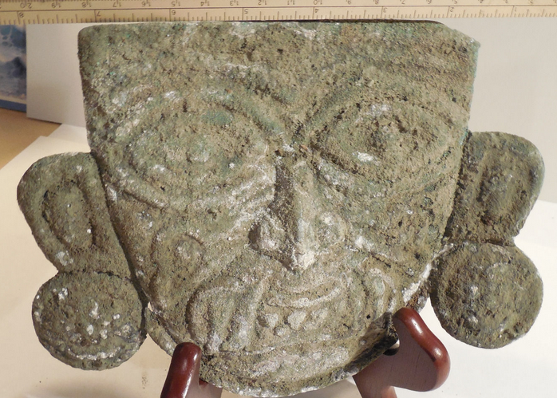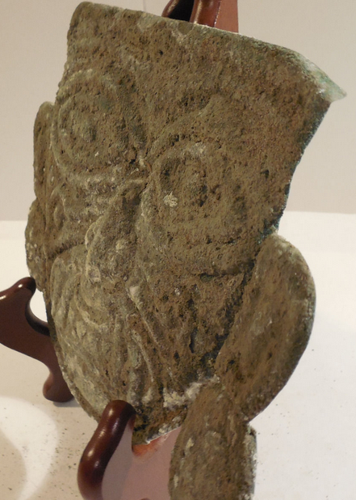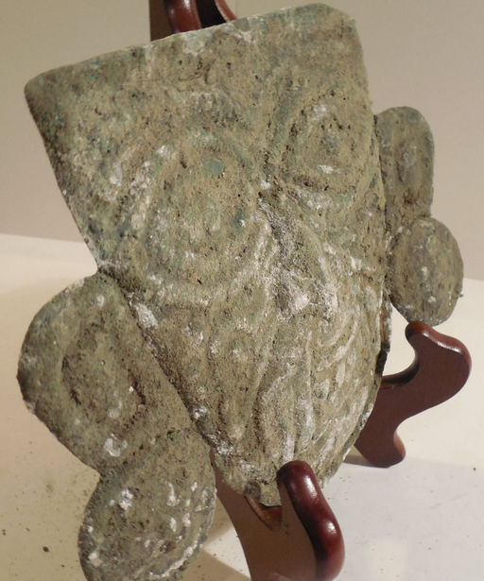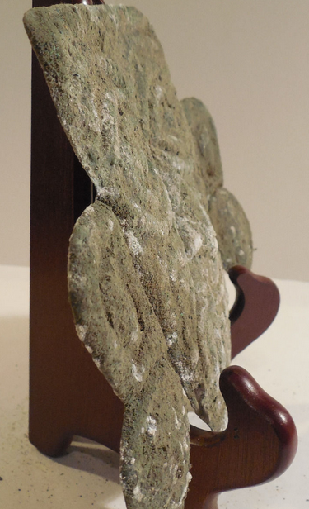

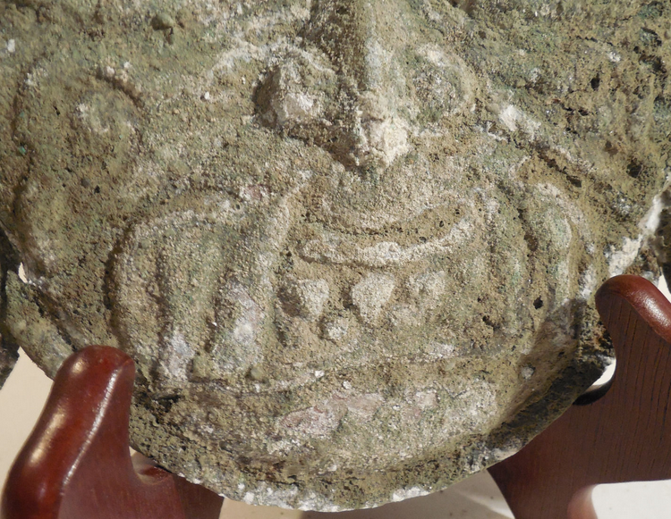

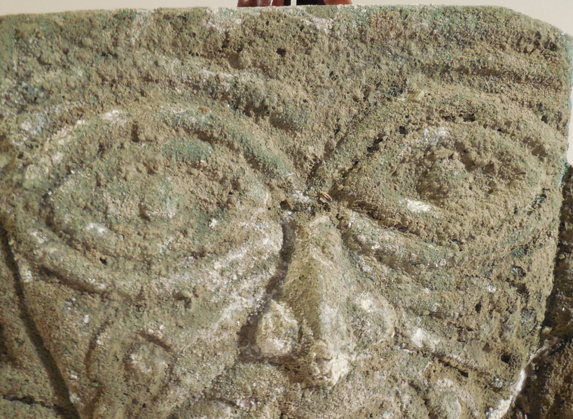

**Order details**

**Sales order**

Sold by [**ancientgas**](http://myworld.ebay.com/ancientgas) ( [992](http://feedback.ebay.com/ws/eBayISAPI.dll?ViewFeedback&userid=ancientgas" \o "opens in new window or tab" \t "_blank) )

**Delivery package 1 of 1**

Estimated delivery **Wednesday, Dec 30, 2015** **- Monday, Jan 4, 2016**

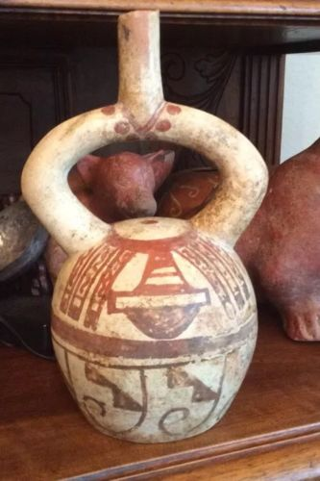

[**Moche IV Blow Bottle 400-600AD Weapon Bundle And Wave + Step Motif**](http://www.ebay.com/itm/221952944734)

|  |  |
| --- | --- |
| Item price | $400.00 |
| Quantity | 1 |
| Item number | 221952944734 |
| Shipping service | USPS Priority Mail Large Flat Rate Box |

**Sales order**

Sold by [**bobski117**](http://myworld.ebay.com/bobski117) ( [2807](http://feedback.ebay.com/ws/eBayISAPI.dll?ViewFeedback&userid=bobski117) )

**Delivery package 1 of 1**

Estimated delivery **Tuesday, Dec 29, 2015** **- Saturday, Jan 2, 2016**

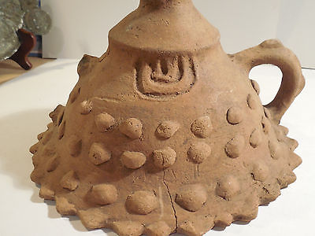

[**Colima Large Incense Lid Shaft Tomb Pre-Columbian Archaic Ancient Artifact Mayan**](http://www.ebay.com/itm/191762068598)

|  |  |
| --- | --- |
| Item price | $34.01 |
| Quantity | 1 |
| Item number | 191762068598 |
| Shipping service | USPS Priority Mail |

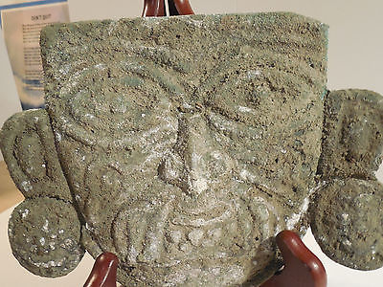

[**Moche Copper Shaman Mask Pre-Columbian Archaic Ancient Artifact Chimu Inca Mayan**](http://www.ebay.com/itm/121843120911)

|  |  |
| --- | --- |
| Item price | $520.00 |
| Quantity | 1 |
| Item number | 121843120911 |
| Shipping service | USPS Priority Mail |